# DENSE_RANK's Output Analysis

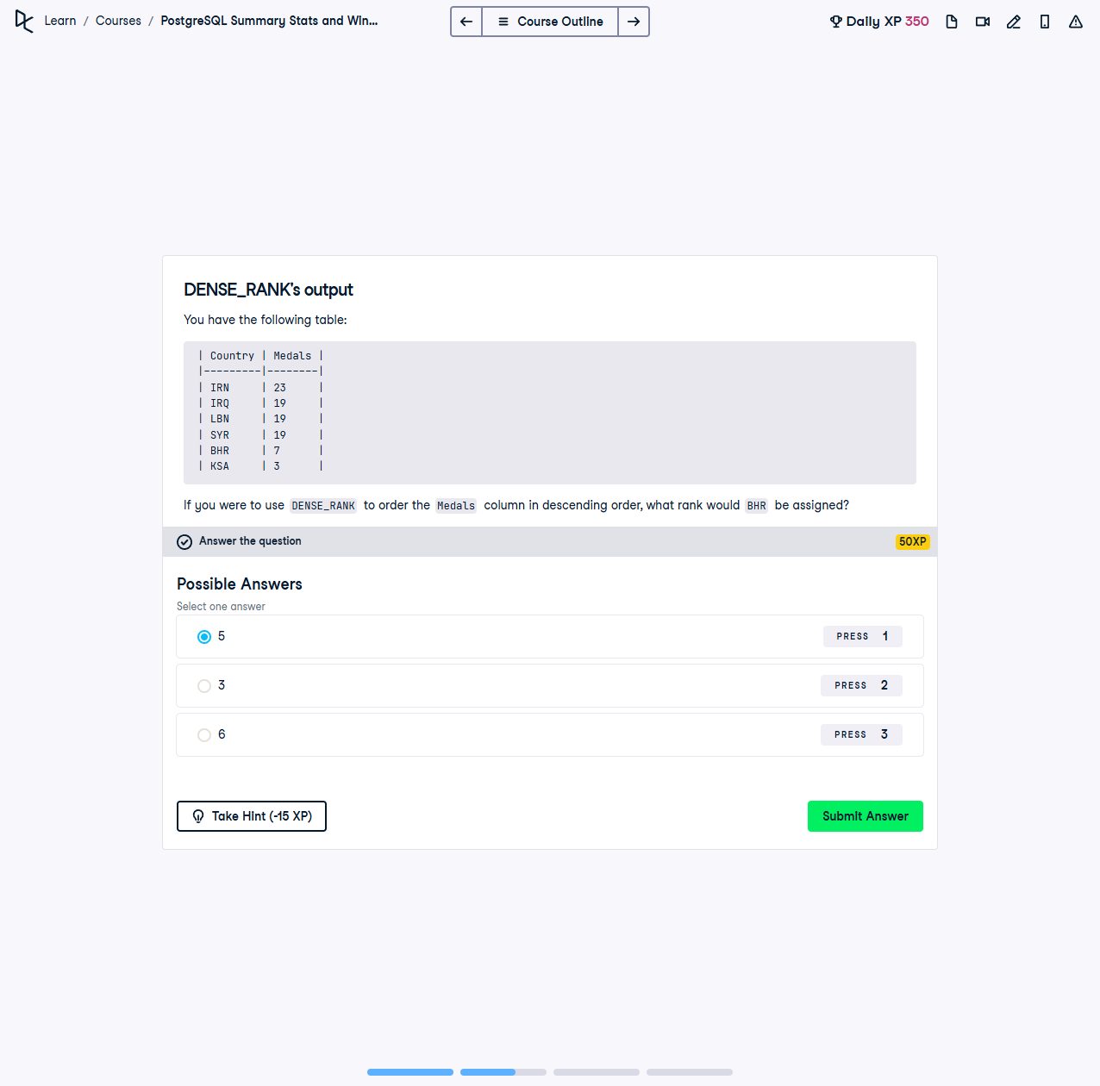

If you were to use `DENSE_RANK()` to order the `Medals` column in descending order, what rank would **BHR** be assigned?

This exercise involves using the `DENSE_RANK()` function to rank countries based on the number of medals they earned. `DENSE_RANK()` assigns consecutive ranks without skipping numbers for ties.

## Table:

|  |  |
| --- | --- |
| Country | Medals |
| IRN | 23 |
| IRQ | 19 |
| LBN | 19 |
| SYR | 19 |
| BHR | 7 |
| KSA | 3 |

## Explanation:

1. `DENSE_RANK()` assigns ranks to rows within a partition of a result set, ordered by a specified column. It does not skip rank numbers for ties.

2. Sorting the table by `Medals DESC` yields:

| Rank | Country | Medals |  
 |------|---------|--------|  
 | 1 | IRN | 23 |  
 | 2 | IRQ | 19 |  
 | 2 | LBN | 19 |  
 | 2 | SYR | 19 |  
 | 3 | BHR | 7 |  
 | 4 | KSA | 3 |

3. Based on this ranking, **BHR** with 7 medals is assigned rank **3**.

## Answer:

**3**